
CALIFORNIA TUMOR TISSUE REGISTRY
Proudly Announces the 138th Semi-Annual Pathology Cancer Seminar:

“Pitfalls and Pearls in Lymph Node and Spleen Pathology”
Guest Speaker…
Peter Banks, MD
The Story of Classification and the CTTR
Dennis P. O’Malley, MD
Clarient, Inc. / GE Healthcare
Aliso Viejo, California

June 7, 2015
8:30 a.m. – 4:45 p.m.

Westin Hotel South Coast Plaza

686 Anton Boulevard

Costa Mesa, California 92626
Phone: (714) 540-2500
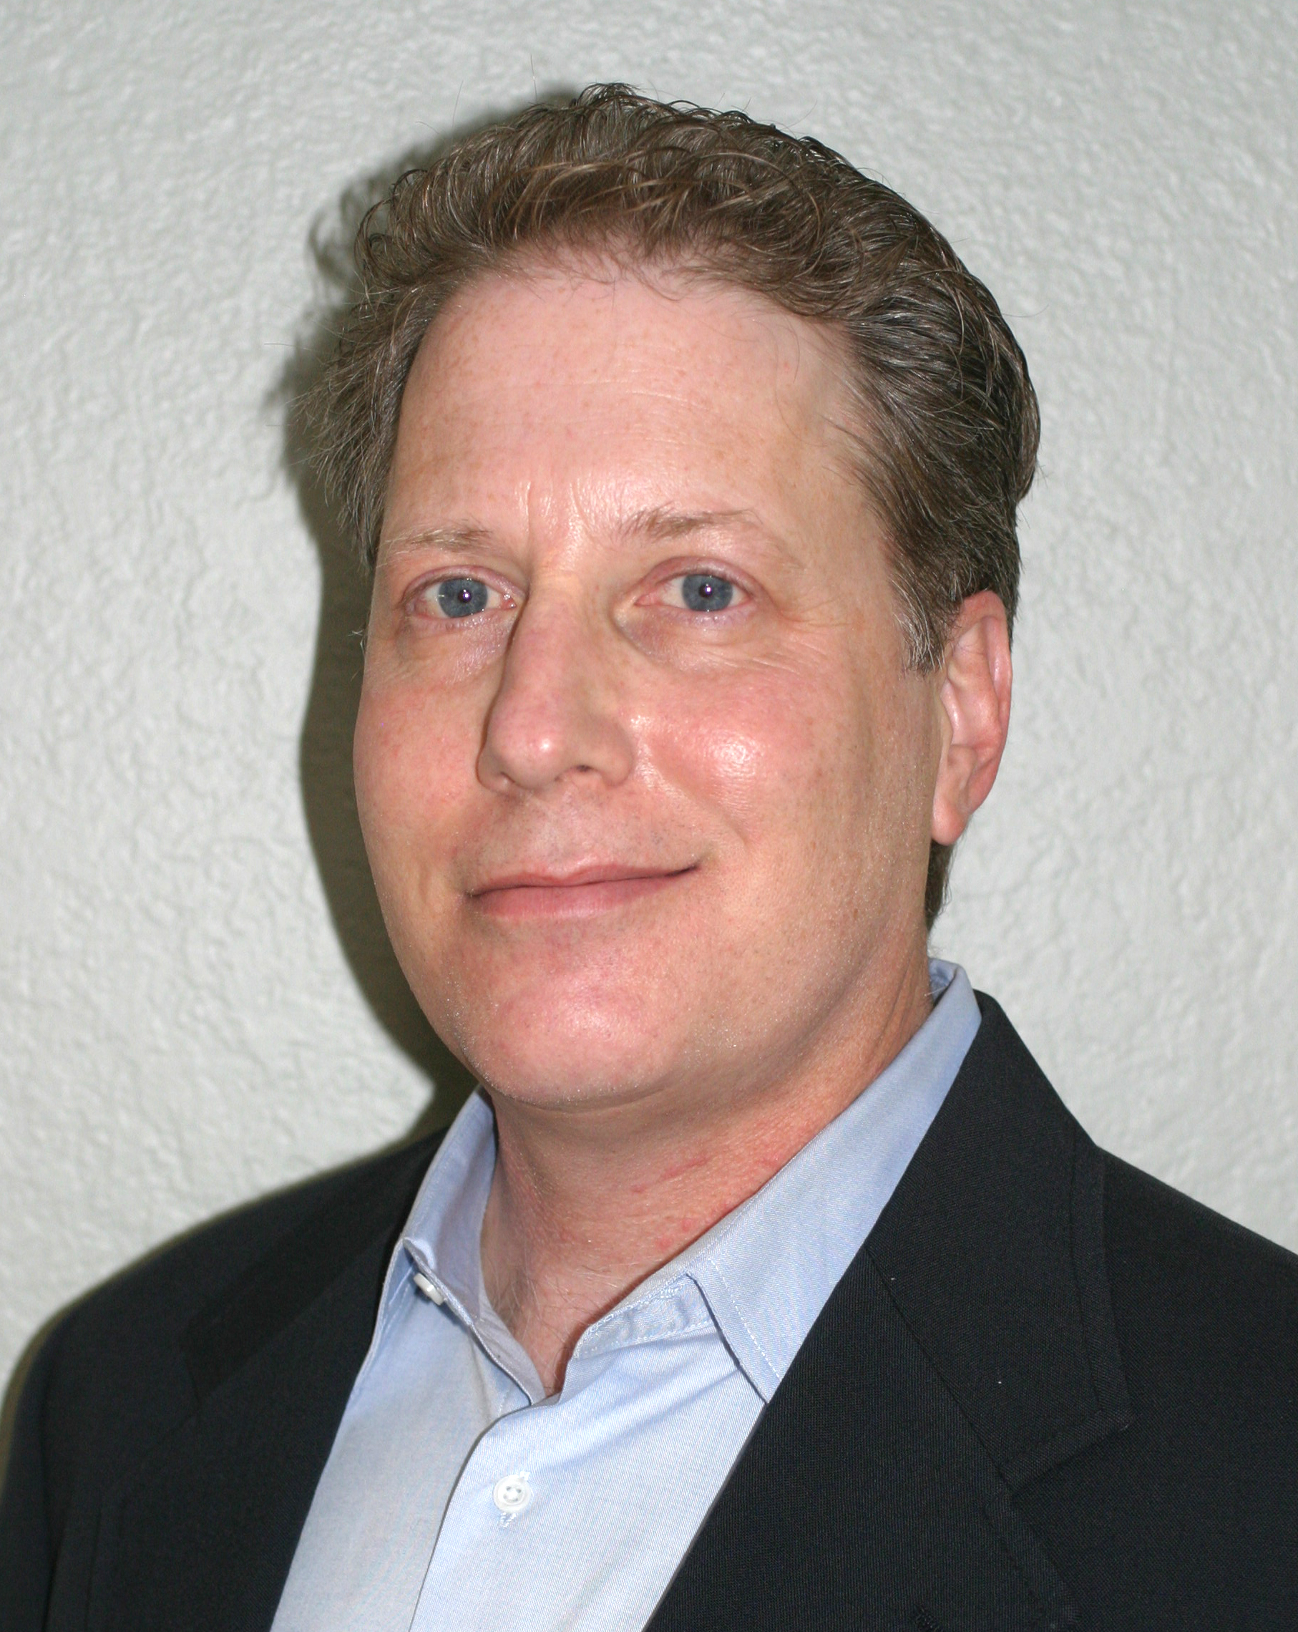

Seminar Objectives: At the conclusion of this seminar, attendees will be able to:
- Improve your skills in identifying lymphomas including use of the appropriate immunohistochemical stains, flow cytometry and other ancillary tests.
- Become familiar with in situ lymphoid lesions as well as new and important benign lesions that may mimic lymphoma.
- Survey pathologic lesions of the spleen and become familiar with important and difficult splenic pathology.

Materials: (“Attendance Only” includes items 1 and 2)
1. 6 hour lecture (Cover seminar objectives, correlate clinical histories, discuss the role of special studies in diagnosis, therapy,
and counseling, and project photographs of the study cases and other illustrative materials)
2. Comprehensive syllabus that includes diagnoses, discussion, and appropriate references from pertinent medical literature
3. Glass slides of representative tumors

CME/SAMs applies only to the day of the seminar. Full Package can earn up to 10 hrs CME and/or SAM, Attendance only can earn up to 6 hrs CME/SAM. This activity is approved for a maximum of 10 SAM credits. Accreditation Statement: Loma Linda School of Medicine is accredited by the Accreditation Council for Continuing medical education for physicians. Loma Linda University School of Medicine designates this live activity and enduring material for a maximum of 10 AMA PRA Category 1 Credit(s) TM. Physicians should claim only the credit commensurate with the extent of their participation in the activity. Disclosure Statement: This program has been planned and implemented in accordance with ACCME essentials and standards. The Loma Linda School of Medicine Office of Continuing Medical Education relies on its CME faculty to provide program content that is free of commercial bias. Therefore, in accordance with ACCME standards, any faculty and/or provider industry relationships will be disclosed and resolved.

PRACTICING PATHOLOGIST |  | RESIDENCY  TEACHING PROGRAM |  | RETIRED PATHOLOGIST |  | RESIDENT /  FELLOW
Current Subscribing Member, Full Package  Non-Subscribing Member, Full Package | $350.00  $370.00 | Full Package | $260.00 | Full Package | $240.00 | Full Package | $210.00
Attendance Only | $230.00 | Attendance Only | $230.00 | Attendance Only | $230.00 | Attendance Only* | FREE
* With a letter verifying residency/fellowship status
** For orders outside the United States of America, please add $40.00
+ Cancellations subject to a 15% overhead charge

Registration Form: (complete and mail, fax, or call CTTR)
Name:
Facility: Please Circle: Check (mail) Visa Master Card
Address: Name on Card:
P.O. Box: Credit Card number:
City, State, Country: Expiration Date: Zip code of billing address:
Zip: Phone: First four numbers of credit card billing address:
Fax: Total Amount:

Signature for Credit Card Authorization:
California Tumor Tissue Registry
11021 Campus Avenue, AH 335
Loma Linda, CA 92350
Phone: (909) 558-4788 / Fax: (909) 558-0188
CTTR@linkline.com

